EXP 2 : MATLAB – BASED MODELLING OF VSB MODULATOR AND DEMODULATOR FOR ANALOG TELEVISION COMMUNICATION APPLICATIONS

SOFTWARE TOOL : MATLAB SOFTWARE

CODE :
clc; clear; close all;

Fs = 1e6; t = 0:1/Fs:2e-3;
fm = 5e3; fc = 100e3;

% Message signal
m = cos(2*pi*fm*t);

% Carrier and DSB-SC signal
c = cos(2*pi*fc*t);
dsb = m.*c;

% VSB modulation: retain upper sideband + small lower sideband
[b,a] = butter(4,[fc fc+fm]/(Fs/2),'bandpass');
vsb = filter(b,a,dsb);

% Coherent demodulation
demod = vsb.*(2*c);
[b2,a2] = butter(4,2*fm/(Fs/2),'low');
out = filter(b2,a2,demod);

figure;
subplot(4,1,1),plot(t,m),grid on
title('Message Signal'),xlabel('Time (s)')

subplot(4,1,2),plot(t,dsb),grid on
title('DSB-SC Signal'),xlabel('Time (s)')

subplot(4,1,3),plot(t,vsb),grid on
title('VSB Modulated Signal'),xlabel('Time (s)')

subplot(4,1,4),plot(t,out),grid on
title('VSB Demodulated Signal'),xlabel('Time (s)')

MODEL GRAPH :
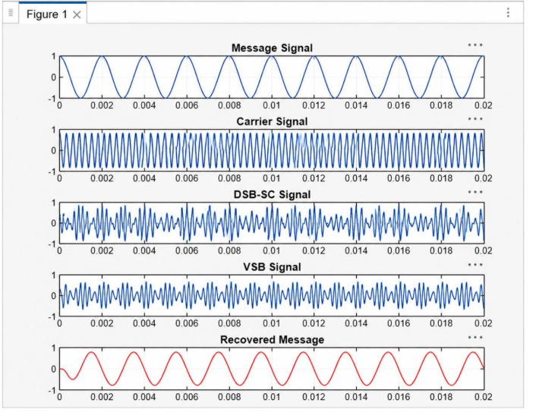
RESULT :
